**CURRICULUM- VITAE**

**SARFINA KULLU**

F-199C, street no. 17,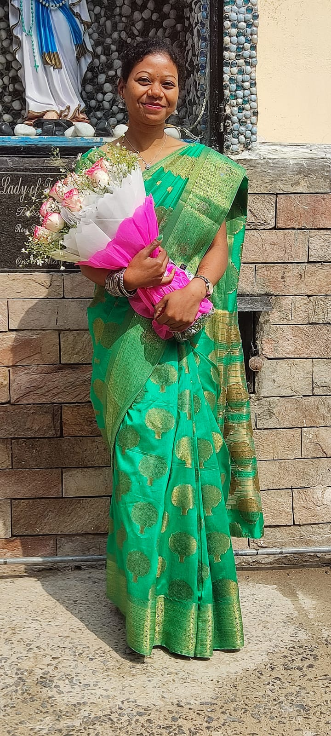

Phase 6, Aya Nagar,

New Delhi – 110047

Contact no. –9311127185

Email ID - kullus857@gmail.com

**Post Applied for: PRT English and TGT English**

**CAREER OBJECTIVE**

An organized professional with proven teaching, guidance and counseling skills. Posses a strong track record in improving test scores and teaching effectively. Ability to be a team player and resolve problems and conflicts professionally. Skilled at communicating complex information in a simple and entertaining manner. Looking to contribute my knowledge and skills in a school that offers a genuine opportunity for career progression.

**EDUCATIONAL QUALIFICATION**

|  |  |  |  |
| --- | --- | --- | --- |
| **Degree/course** | **University/board** | **Year of passing** | **percentage** |
| 10th | CBSE | 2006 | 58% |
| 12TH | CBSE | 2008 | 52% |
| B.A.(program) | DU | 2012 | 50% |
| B.ed | MDU | 2014 | 65% |
| M.A.English | IGNOU | 2022 | 55% |
| CTET paper 1 | CBSE | 2016 | 70% |
| CTET paper 2 | CBSE | 2019 | 62% |

**STRENGTH**

* Excellent with children
* Communication skills
* Interpersonal skills
* Time management skills
* MS office suite
* Modern classroom technology

**PROFESSIONAL EXPERIENCE**

* **St. Angel's school** (1st July 2022 to present) - **class teacher of class 4**
* **Gyan Kunj Public school(**5th July 2021 to 30 June 2022 **)- *taught English classes 6,7and 8***
* **Father Agnel school (**1st April 2019 to 30th November 2019**)-*taught English, Hindi and Math classes 1 and 2***
* **Baba Public school (**3rd July 2015 to 31st March 2018**) – *taught English, Hindi, Math, Science and Social studies Mother teacher of class 4th***
* **Bharat Vashisht Vidya Mandir (**12th September 2013 to 10th February 2015**)- *taught English classes 6th, 7th and 8th***

***class teacher of class 6th***

**PERSONAL DETAILS**

Father’s Name - Poluse Kullu

Date of Birth - 13/09/1990

Gender - Female

Nationality - Indian

Religion - Christian

Language Known - Hindi and English

**HOBBIES**

* Watching movies
* Listening music
* Reading books.

**REFERENCES**

1.Ms. Reena - Principal at Swarn Public School

2. Ms. Komal - Teacher at St. Mary Public School

**DECLARATION**

I hereby declare that the information furnished above is true to the best of my knowledge.

Date:14.07.2023

Place:Delhi (Sarfina Kullu)